Community Policing Update  Your local officers remain committed to keeping our community safe and reassured. We continue to carry out high-visibility patrols across the area, focusing on building positive relationships and deterring criminal activity.  Off Road Bikes  Off road bikes are still a main issue in the area. These bikes must not be ridden on roads, pavements, or public spaces and can pose a risk to others.  We’re carrying out patrols and will take action where offences are identified, including seizing bikes. Please continue to report incidents with as much detail as possible.  Please be vigilant  There have been reports of people posing as police officers and approaching members of the public. When challenged and asked for their badge number, they have driven away from the area.  Always check identification if approached by someone claiming to be a police officer. Genuine officers will be happy to provide proof of identity.  If you experience a similar incident or have any information, please contact Kent Police via 101, or 999 if a crime is in progress.  Fire Safety Warning  There have been reports and concerns regarding people using disposable barbecues on dry grass, causing fires.  With the current dry conditions, fires can spread quickly and pose a risk to people, wildlife and property. Please do not use disposable barbecues on dry grass or in open areas with dry vegetation.  If you see a fire, call 999 immediately.  - Community Engagement: We are committed to engaging with the Greenhill and Westbay Wards community. This includes holding regular community meetings, which are advertised via My Community Voice. We want to hear your concerns and work together to find solutions.  We are committed to keeping you informed. We publish this monthly newsletter and provide updates on local crime trends and the work we are doing to address these issues on My Community Voice. |   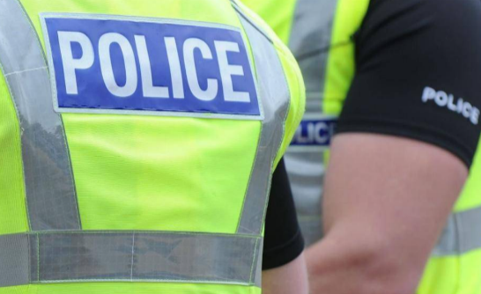  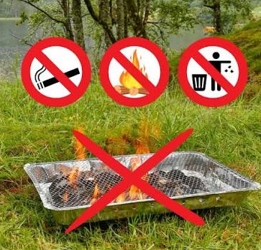
Next month’s engagements:  - Hampton Car Park 21/09/26 10:00-11:00hours  - Greenhill Church 22/09/26 10:00-11:00hours | Your local officer is;  PC 15918 TOTTEN

Good work report:

Officers recently stopped an individual riding an e-scooter and the vehicle was seized.

We would like to thank those who continue to report concerns regarding the use of e-scooters in our area. Information provided by the public helps us take positive action and keep our roads and communities safe.

Please continue to report any concerns or incidents involving e-scooters via 101 or Kent Police's online reporting system. In an emergency, always call 999.

Your reports make a difference. Thank you for your support.

