Community Policing Update  Your local officers remain committed to keeping our community safe and reassured. We continue to carry out high-visibility patrols across the area, focusing on building positive relationships and deterring criminal activity.  Motorbike thefts  We have recently received reports of motorbike thefts in the area. We are encouraging owners to take extra precautions to protect their vehicles by using locks, alarms, and secure parking where possible.  If you witness any suspicious activity or have information that may assist us, please report it. Together, we can help reduce motorbike crime in our community.  Dangerous Dogs  We have received reports of dangerous and out-of-control dogs within the area. Dog owners are reminded of their responsibility to ensure their dogs are kept under control at all times and do not pose a risk to members of the public or other animals.  If you witness a dog acting aggressively or have concerns about a dangerous dog, please report the incident to us. Your information helps us take appropriate action and keep our communities safe.  Theft of Building Materials  We have received reports of building materials being stolen from construction sites and properties within the area. We are reminding residents and contractors to remain vigilant and, where possible, ensure materials are stored securely and valuable items are marked.  - Community Engagement: We are committed to engaging with the Greenhill and Westbay Wards community. This includes holding regular community meetings, which are advertised via My Community Voice. We want to hear your concerns and work together to find solutions.  We are committed to keeping you informed. We publish this monthly newsletter and provide updates on local crime trends and the work we are doing to address these issues on My Community Voice. | 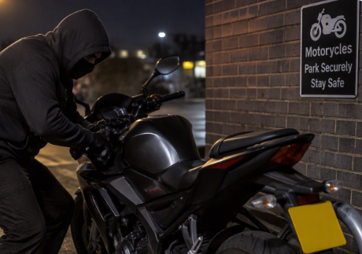  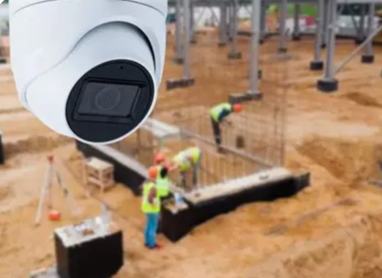
Next month’s engagements:  - Hampton Car Park 14/10/026 13:00-14:00hours  - Greenhill Church 06/10/26 10:00-11:00hours | Your local officers are;  PC 15918 TOTTEN

