Community Policing Update  Your local officers remain committed to keeping our community safe and reassured. We continue to carry out high-visibility patrols across the area, focusing on building positive relationships and deterring criminal activity.  Fraud  There have been reports for fraud related activity in the area. Please be aware of fraudsters making phone calls claiming money has been withdrawn from your bank account. These callers may pretend to be from your bank, the police, or a fraud team and will often try to create panic to obtain your personal or banking details.  Remember:  - Never share PINs, passwords, or security codes over the phone.  - Do not transfer money to a "safe account".  - If in doubt, hang up and contact your bank using an official number.  Stay vigilant and report any suspicious calls to your bank and Action Fraud.  Off Road Bikes  As the summer holidays begin, we’ve had multiple reports of off-road bikes being used illegally in our area. These bikes must not be ridden on roads, pavements, or public spaces and can pose a risk to others.  Under Section 59 powers, riders causing nuisance or alarm can receive a warning, with bikes liable for seizure if offences continue. We are also seizing bikes being used unlawfully.  We’re carrying out patrols and will take action where offences are identified, including seizing bikes. Please continue to report incidents with as much detail as possible.  - Community Engagement: We are committed to engaging with the North Rural Wards community. This includes holding regular community meetings, which are advertised via My Community Voice. We want to hear your concerns and work together to find solutions.  We are committed to keeping you informed. We publish this monthly newsletter and provide updates on local crime trends and the work we are doing to address these issues on My Community Voice. |   
Next month’s engagements:  - Blean Village, School Lane 19th August 2026 14:00-15:00hours – BIKE MARKING EVENT  - Hersden Community Centre 7th and 28th August 10:00-11:00hours – BIKE MARKING EVENT  - Coffee Corner, Herne Bay Road 10th August 10:00-11:00hours – BIKE MARKING EVENT  - Hersden Community Centre 29th August 2026 10:00-14:00 hours – EMERGENCY SERVICES DAY | Your local officers are;  PC 30838 PARKINSON WELLARD  PCSO 62956 SINCLAIR

Upcoming events to look out for!

Your local officers will be holding an upcoming bike marking event in the area to help prevent theft. Bring your bike along to have it security-marked and registered.
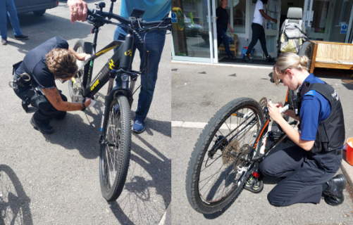
Keep an eye on our channels for dates and locations—we look forward to seeing you there!

