
MONTHLY NEWSLETTER
JULY 2026
Get the latest crime statistics by visiting: www.kent.police.uk/yourarea

Broadstairs Ward Newsletter – July Edition
From PC 14643 Absolon
Hello Broadstairs,
- In the last month I have being involved in the arrest of three persons. One of these was in Broadstairs on a recent hot day. A person refused to give their details when requested after being abusive to police. Cannabis was located on their person, and they were dispersed from town and issued a community resolution.
- You may have seen from a previous post I have continued to be in the town on hot days and issued dispersal notices to those causing anti-social behaviour.
- In between policing the beaches. I have been able to complete some other work. I arrested male after he has assaulted a member of staff in a supermarket, we located him still in the area, a swift arrest resulted in the male being charged with offences relating to assault
- Whilst on mobile patrol a colleague and I have used local knowledge to locate a violent offender who we arrested within 30 mins of the alleged offences. This person has since been remanded to prison awaiting court proceedings.
- After complaints raised about obstructive parking outside a local business, I have made a concerted effort to speak to said business on several occasions about this and noticed a marked improvement on seeing cars blocking pavements.
- We are making a big push into my community voice, I appreciate many people will be reading this via this. However, if there is anyone you know who might be interested. Please make them aware as we wish to make the community as large as possible.
- The next police surgery will be on Friday 7TH AUGUST 2026 at 1500. This is being held at Broadstairs library at 1500 hours. If you wish to speak to me in person about any issues please attend.
Thank you PC 14643 ABSOLON
MONTHLY NEWSLETTER
APRIL 2026
Get the latest crime statistics by visiting: www.kent.police.uk/yourarea

MONTHLY NEWSLETTER
JULY 2026
Get the latest crime statistics by visiting: www.kent.police.uk/yourarea
You may have already heard about "My Community Voice" — a two-way communication platform that helps strengthen the connection between the police and the community.
Through this tool, we share updates on local incidents, promote community events, run surveys, and issue appeals for information. It also gives residents a direct way to engage with us and have their voices heard.
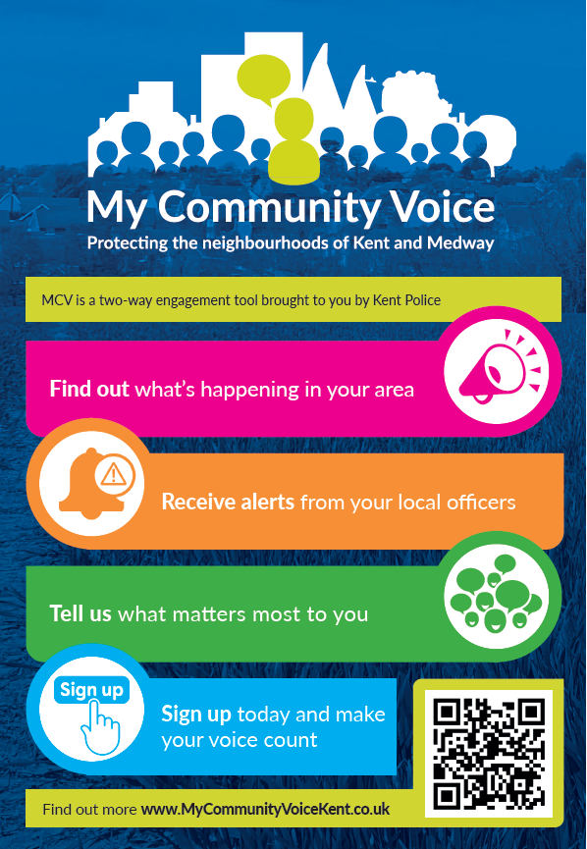
📱 Please scan the QR code below to sign up and stay informed.

