
Targeted Activity: Possession of Catapults

Get the latest crime statistics
by
v
isiting:

www.kent.police.uk/yourare
a

Beltinge & Reculver

Ward

newsletter

May
202666

.

Here is your monthly update on the work carried out across the wards of Beltinge and Reculver over the past few weeks. Thank you to all residents who continue to report concerns and support our policing efforts. Your information helps us target issues effectively and keep our community safe.

Over the past month:
- My colleagues and I responded to an incident whereby three male youths were stopped and subsequently searched; the youths were found to be in possession of catapults.
- All catapults were seized, and appropriate action was taken in relation to each individual.
- In a separate, unrelated incident, another youth was stopped and found to be carrying ball bearing ammunition intended for use with a catapult. These items were also seized.

These proactive interventions have helped to prevent the potential for anti-social behaviour and damage to property in the community.

We will continue to take firm action where necessary and encourage residents to report any concerns so proactive stops can take place.

Road Safety – Speed Enforcement Activity

Road safety continues to be a key priority within the ward, with a focus on reducing speeding and improving safety for all road users.

Over the past month:

- I have been conducting speed enforcement checks using a handheld speed detection device in identified hotspot areas.

- These checks have been carried out at varying times to target periods where speeding is most commonly reported.

- My colleagues and I have issued multiple Traffic Offence Reports (TORs) to motorists found to be exceeding the speed limit.

These proactive measures are aimed at both enforcing the law and educating drivers around the importance of adhering to speed limits.

We will continue to carry out high-visibility and targeted speed checks to address community concerns and keep our roads safe.
“Image of Speed Gun in use on Island Road by PC Roy”

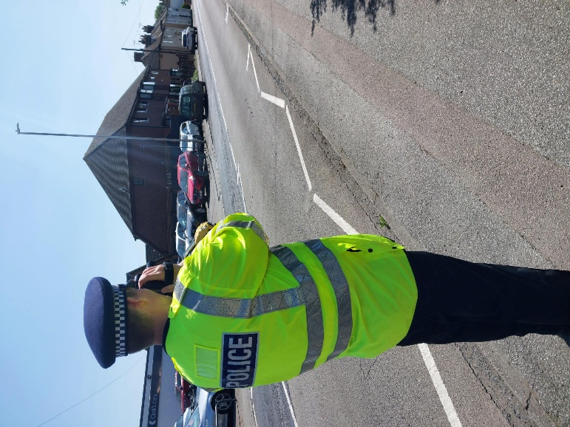

Ongoing Work: Drug Use and Anti-Social Behaviour at Residential Address

I am currently investigating ongoing reports linked to a residential block of flats within the ward, where concerns have been raised regarding persistent drug use and suspected drug dealing by an occupant.

Over the past month:

- I have been reviewing multiple reports and intelligence, identifying patterns of behaviour linked to ongoing drug use, suspected dealing, and associated disturbances affecting neighbouring properties.

- I have been gathering evidence to support further action, including documenting recurring incidents, times of activity, and the wider impact on the community.

- I will be liaising closely with the relevant housing officer to address potential breaches of tenancy conditions and to ensure a coordinated approach in dealing with the issues.

- I am actively exploring the use of a Closure Order for the address; I have previously had success using Closure Orders to tackle similar issues, and they have proven to be an effective tool in stopping anti-social behaviour, drug use, and ongoing disturbances, providing immediate relief to affected residents.

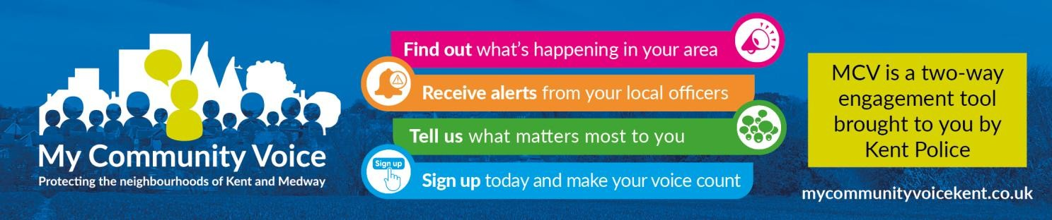
- Supporting our community: By working closely with residents, local partners, and community groups, we aim to build trust, improve safety, and create stronger relationships across the area. Whether it’s providing reassurance, acting on concerns, or helping vulnerable individuals access the support they need, our focus is on being visible, approachable, and proactive. Together, we can continue making our neighbourhood a safer and more positive place to live.

1


Community Engagement: We are committed to engaging with the Coastal Wards community. This includes holding regular community meetings, which are advertised via My Community Voice. We want to hear your concerns and work together to find solutions.

We are committed to keeping you informed. We publish this monthly newsletter and provide updates on local crime trends and the work we are doing to address these issues on My Community Voice.

2

Next month’s engagements:  - Friday 5th June 2026 10:00 – 11:30 – (Heron Leisure Centre) HatHats Coffee, Herne Bay Central, William Street, Herne Bay, CT6 5NX  - Tuesday 16th June 2026 10:30 -12:00 – HatHats Coffee, Reculver, Ct6 6SS.  - Wednesday 24th June 2026 15:00 -16:30 – Costa Coffee, 6 The Boulevard, Herne Bay, CT6 6GZ. | Your local officer:  PC Jack Roy

