
June Monthly Ward Newsletter

Get the latest crime statistics
by
v
isiting:

www.kent.police.uk/yourare
a

Beltinge & Reculver

Ward

newsletter

June
202666

.

Here is your monthly update on the work carried out across the wards of Beltinge and Reculver over the past month. Thank you to all residents who continue to report concerns and support our policing efforts. Your information helps us target issues effectively and keep our community safe.

June was another busy month, with a strong emphasis on community engagement, visibility, and road safety throughout the wards. Engaging with residents remains a key part of neighbourhood policing, and June provided several opportunities to meet members of the public, discuss local concerns, and strengthen community relationships.

Reculver Summer Fair
I attended the Reculver Summer Fair as the local beat officer, where I engaged with many members of the community on a great community day. The Reculver Summer Fair was a well-attended event and had a number of community stalls, activities / games, live performances, refreshments, and much more.
We had set up one of our Kent Police community stalls, where we gave out free security UV marker pens, sunglasses, security purse bells, stickers, colouring in sheets, colouring pencils, security leaflets, and many more items.
Our police vehicles proved extremely popular with children and families. Attendees were given the opportunity to sit in the marked police vehicle and activate the blue lights and sirens. A selection of police equipment and uniform were also on display, allowing children to try on uniform and learn more about the role of the police and the equipment used in everyday policing.
The police display was very well received throughout the event and attracted a steady flow of visitors of all ages. Members of the public welcomed the opportunity to speak with officers in an informal setting and enjoyed the friendly and interactive nature of the display.
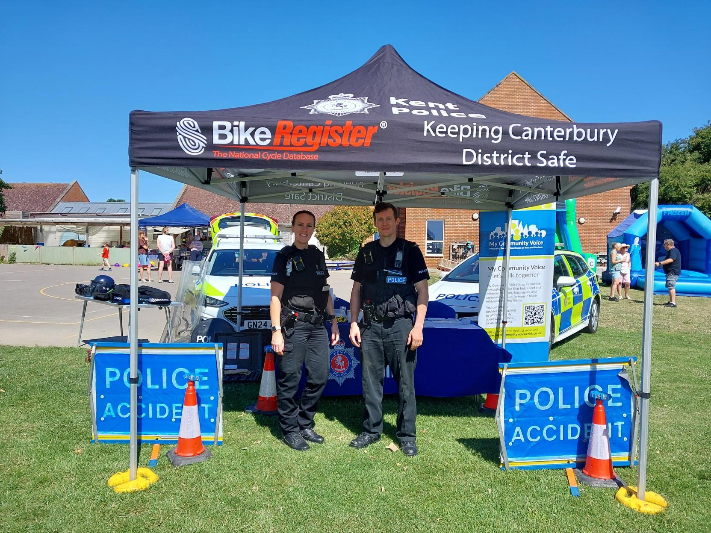

Herne Bay Pride
I also attended Herne Bay Pride at the beginning of the month, joining residents, organisers, and visitors in celebrating diversity and inclusion within our community. The event provided an excellent opportunity to engage with attendees, discuss local issues, and reinforce Kent Police's commitment to supporting all members of our community.
My colleagues and I set up a Kent Police stall, and we spoke to members of the public about My Community Voice and all the different features the two-engagement tool offers to keep up members of public up to date with local news and engagement with the police.

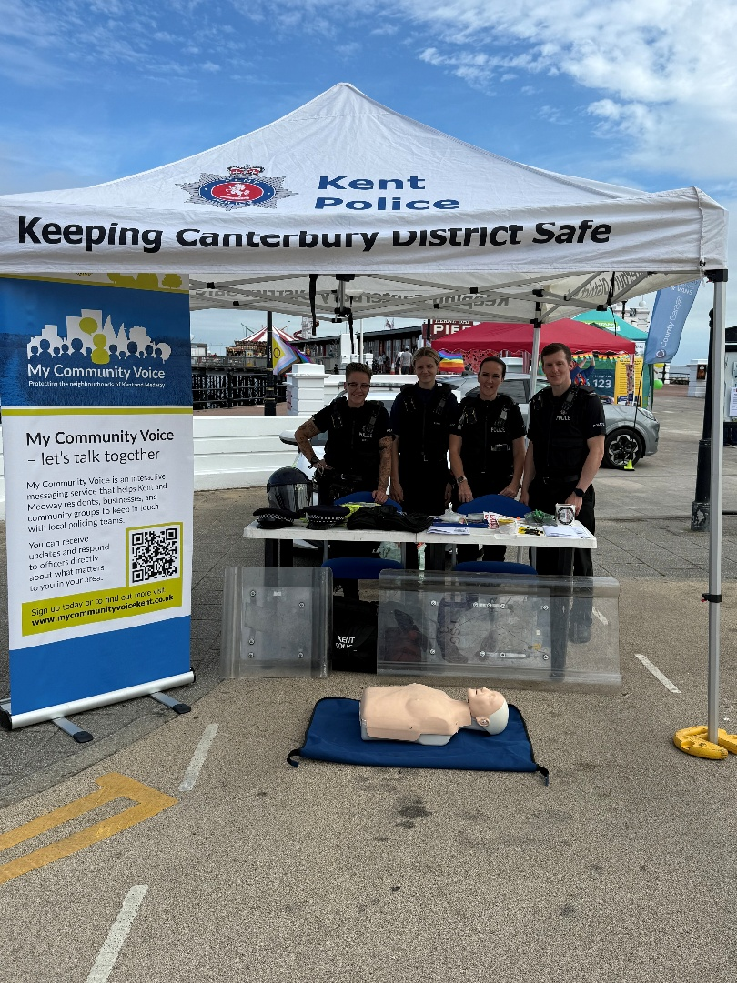

My Community Voice Engagement Stand – Sainsbury's, Altira Business Park
I also hosted a My Community Engagement Stand at Sainsbury's, Altira Business Park in Beltinge. The stand enabled face-to-face conversations to be held to help us understand what matters most to the community and how we can continue to provide effective local policing. Local residents spoke to me about ongoing neighbour disputes, speeding concerns and anti-social behaviour. Thank you to those that took the time to stop and speak with me, and I have planned follow up action on the issues that were discussed.

Continued Work in the Community
- I have continued to focus on tackling anti-social behaviour and addressing local policing priorities. I have been working closely with housing officers to identify, disrupt, and enforce against individuals responsible for anti-social behaviour within a block of flats, and I have a planned a joint visit with the housing officer to the block of flats next week.

- I have also carried out speed checks utilising the speed gun in response to concerns raised by members of the public regarding excessive vehicle speeds. I know speeding vehicles remains a high priority in the community and I have more speed enforcement operations planned for the month of July.

Looking Ahead
As we move into the summer months, I will continue to focus on community engagement, visibility patrols, tackling anti-social behaviour, and addressing priority concerns raised by residents. I encourage anyone with concerns or information about crime in their area to speak with me when out on patrol or report matters through the appropriate Kent Police channels.

Thank you to everyone who took the time to stop, chat, and engage with us during June. Your feedback and support are invaluable in helping to keep our communities safe.


Community Engagement: We are committed to engaging with the Coastal Wards community. This includes holding regular community meetings, which are advertised via My Community Voice. We want to hear your concerns and work together to find solutions.

We are committed to keeping you informed. We publish this monthly newsletter and provide updates on local crime trends and the work we are doing to address these issues on My Community Voice.
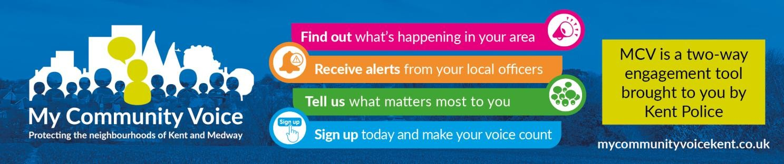

2

Next month’s engagements:  - Coffee with a Cop – Thursday 9th July 2026 10:00 – 11:30 – (Heron Leisure Centre) HatHats Coffee, Herne Bay Central, William Street, Herne Bay, CT6 5NX  - Coffee with a Cop – Tuesday 14th July 2026 10:00 -11:30 – HatHats Coffee, Reculver, Ct6 6SS.  - MCV Engagement Stall – Sunday 19th July 2026 13:00 – 14:30 – Sainsbury’s, 6 The Boulevard, Herne Bay, CT6 6GZ.  - Coffee with a Cop – Tuesday 28th July 2026 15:00 -16:30 – Costa Coffee, 6 The Boulevard, Herne Bay, CT6 6GZ. | Your local officer:  PC Jack Roy

