Introduction  I wanted to introduce myself as your new Local Beat Officer, PC Totten.  I am committed to working closely with the community to address local concerns and improve neighbourhood safety. As part of this role, I will be holding regular engagement opportunities, giving residents the chance to speak directly with their local officer, raise any issues, and receive advice or support.  In addition, I will be conducting frequent high-visibility foot patrols throughout the area. These patrols are designed to provide reassurance to the community, deter crime and anti-social behaviour, and ensure a consistent police presence in key locations. By being out and about, I aim to build positive relationships with residents and help create a safer environment for everyone.  Community Policing Update  Your local officers remain committed to keeping our community safe and reassured. We continue to carry out high-visibility patrols across the area, focusing on building positive relationships and deterring criminal activity.  E-scooters and E-bikes  E-scooters and E-bikes are becoming more common in the area, and it is important that they are used safely and in line with current legislation. Local officers are carrying out high visibility foot patrols to engage with residents, offer advice, and address any misuse. These patrols aim to promote safer use, increase awareness and discourage any anti-social behaviour to e-scooters and e-bikes.  - Community Engagement: We are committed to engaging with the Greenhill and Westbay community. This includes holding regular community meetings, which are advertised via My Community Voice. We want to hear your concerns and work together to find solutions.  We are committed to keeping you informed. We publish this monthly newsletter and provide updates on local crime trends and the work we are doing to address these issues on My Community Voice. | 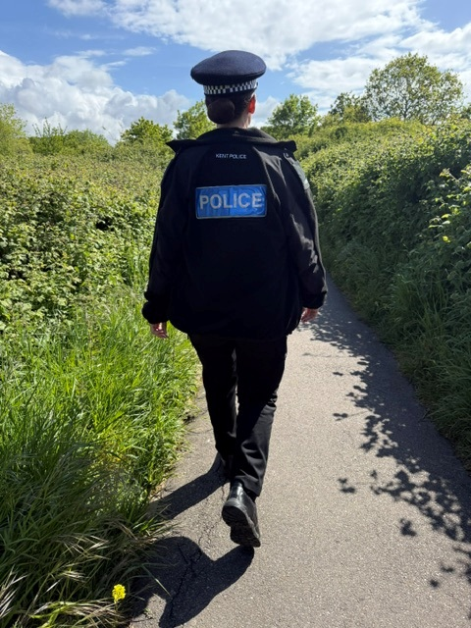  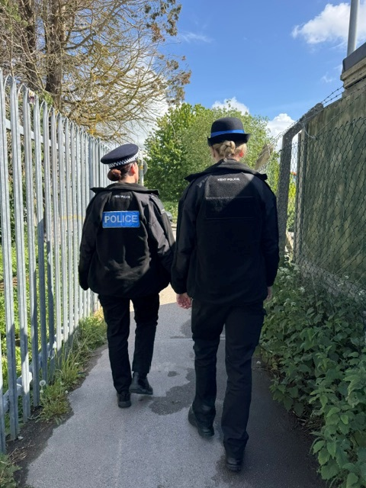
Next month’s engagements:  - Engagement Car – Hampton Car Park 5th JUNE 2026 10:00-11:00hours  - St Peters Church, Herne Drive, Greenhill 16th JUNE 2026 10:00-11:00hours.  - Canterbury Garden Centre, Canterbury Road 16th JUNE 2026 09:00-10:00hours | Your local officers are;  PC 15918 TOTTEN

Good work report

There have been reports of youths using catapults and causing harm to wildlife in Herne Bay. In response, high visibility foot patrols have been carried out, and dispersal orders have been put in place to address the issue.

As a result of these actions, a number of youths were stopped and searched, during which catapults were found. Section 34 dispersal notices were issued, requiring those involved to leave the area and not return for 24 hours.

