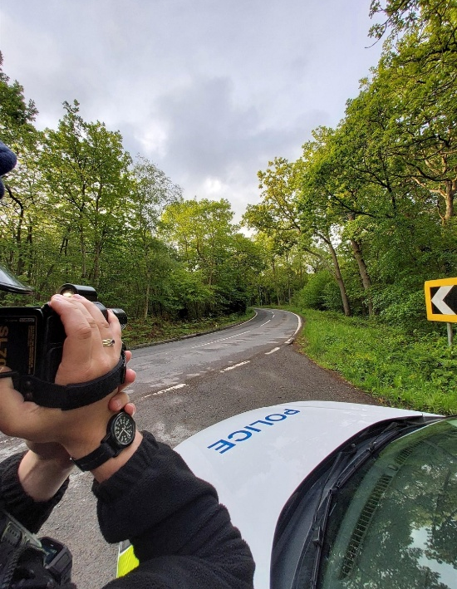
Community Policing Update  Your local officers remain committed to keeping our community safe and reassured. We continue to carry out high-visibility patrols across the area, focusing on building positive relationships and deterring criminal activity.  Speeding  Speeding continues to be a key concern within the area and local officers are actively working to address the issue. Regular speed checks are being carried out using handheld devices in identified hotspot locations, alongside increase high visibility patrols to deter unsafe driving.  We aim to improve road safety, reduce the risk of collisions and reassure residents that concerns are being taken seriously. Officers with continue to monitor the situation and take appropriate enforcement action where necessary. We encourage residents to report any ongoing issues so that targeted action can be taken.  Cold callers  There have been reports of cold callers operating I the area. While callers may be legitimate, residents are advised to remain cautious when approached at their door, particularly if they feel pressured or uncomfortable. Always ask for identification and take time to verify who they are before engaging.  Do not feel obliged to let anyone into your home or agree to services on the spot. It is recommended to use trusted traders who are pre-approved or recommended. If you are unsure or feel something is not right, trust your instincts and report any concerns to Kent Police via 101 or 999 in an emergency. Looking out for neighbours, particularly those who may be more vulnerable, can also help keep our community safe.  - Community Engagement: We are committed to engaging with the North Rural Wards community. This includes holding regular community meetings, which are advertised via My Community Voice. We want to hear your concerns and work together to find solutions.  We are committed to keeping you informed. We publish this monthly newsletter and provide updates on local crime trends and the work we are doing to address these issues on My Community Voice. | 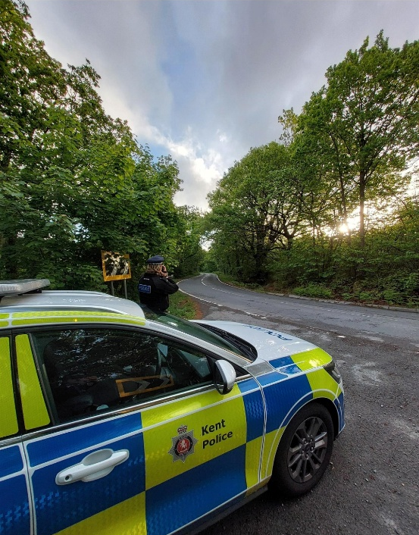
Next month’s engagements:  - Coffee Corner, Herne Bay Road 1st JUNE 2026 13:00-14:00hours  - Blean Village, School Lane 10th JUNE 2026 11:00-12:00hours  - Hersden Community Centre 12th JUNE 2026 10:00-11:00hours  - Canterbury Garden Centre, Canterbury Road 16th JUNE 2026 09:00-10:00hours | Your local officers are;  PC 30838 PARKINSON WELLARD  PCSO 62956 SINCLAIR

Good work report

A report was received regarding a vehicle that had been left in Hersden without number plates. Local officers attended to investigate and found that the vehicle had no valid tax, MOT, or insurance for the past two years. Further enquiries revealed that the number plates associated with the vehicle had been cloned. This vehicle is now off the road.


