Community Policing Update  Your local officers remain committed to keeping our community safe and reassured. We continue to carry out high-visibility patrols across the area, focusing on building positive relationships and deterring criminal activity.  Nuisance Vehicles  Off-road bikes and nuisance vehicles remain an ongoing issue in the area. As part of efforts to tackle this problem, local officers have been conducting high-visibility patrols. During one such patrol, two riders made off from officers; however, the motorbike was recovered and subsequently seized as it had no registration plates.  E-scooters have also been identified as a concern within the area. In response, local officers have located and removed a number of e-scooters from the road.  Please continue to report any incidents to us, as this information helps us target our patrols and take appropriate action.  - Community Engagement: We are committed to engaging with the North Rural Wards community. This includes holding regular community meetings, which are advertised via My Community Voice. We want to hear your concerns and work together to find solutions.  We are committed to keeping you informed. We publish this monthly newsletter and provide updates on local crime trends and the work we are doing to address these issues on My Community Voice. | 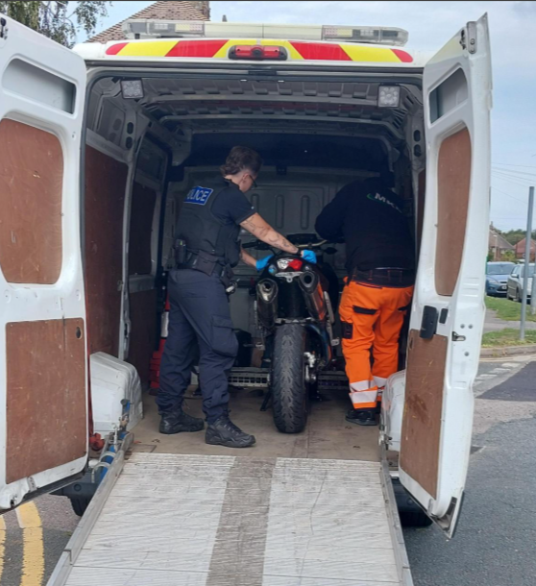
Next month’s engagements:  - Hersden Community Centre 2nd October 2026 10:00-11:00hours  - Blean Village, 14th October 2026 11:00-11:45hours  - Coffee Corner, Herne Bay Road 19th October 2026 13:00-14:00hours  - Hersden Community Centre 30th October 2026 10:00-11:00hours | Your local officers are;  PC 30838 PARKINSON WELLARD  PCSO 62956 SINCLAIR

