Community Policing Update  Your local officers remain committed to keeping our community safe and reassured. We continue to carry out high-visibility patrols across the area, focusing on building positive relationships and deterring criminal activity.  Catapults  We have received reports of catapults being used in the area, which can be dangerous and cause damage or injury. Catapults used to harm wildlife or property may result in police action.  We ask parents and guardians to be aware of how these items are being used and to speak with young people about the risks and consequences.  Please continue to report any incidents so we can take appropriate action and keep our wards safe.  Fraud / Scammers  We’ve had reports of scam phone calls in the area. Fraudsters may pose as banks or police to get your details.  Fraud Prevention Advice  - Stop, Think, Verify before sending money or sharing information.  - Never share passwords, PINs, or security codes.  - Be cautious of unexpected calls, emails, or messages asking for money or personal details.  - Verify requests by contacting the organisation directly using trusted contact details.  - Watch for pressure, urgency, or offers that seem too good to be true.  - Use strong passwords and enable multi-factor authentication.  - Report suspected fraud to your bank immediately and keep any evidence.  Remember: If in doubt, don't give it out.  .  - Community Engagement: We are committed to engaging with the Greenhill and Westbay community. This includes holding regular community meetings, which are advertised via My Community Voice. We want to hear your concerns and work together to find solutions.  We are committed to keeping you informed. We publish this monthly newsletter and provide updates on local crime trends and the work we are doing to address these issues on My Community Voice. | 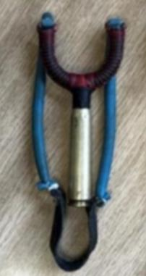  
Next month’s engagements:  - Engagement Car – Hampton Car Park 8th JULY 2026 10:00-11:00hours  - St Peters Church, Herne Drive, Greenhill 14th JULY 2026 10:00-11:00hours.  - Canterbury Garden Centre, Canterbury Road 29th JULY 2026 09:00-10:00hours | Your local officer is;  PC 15918 TOTTEN

Good work report
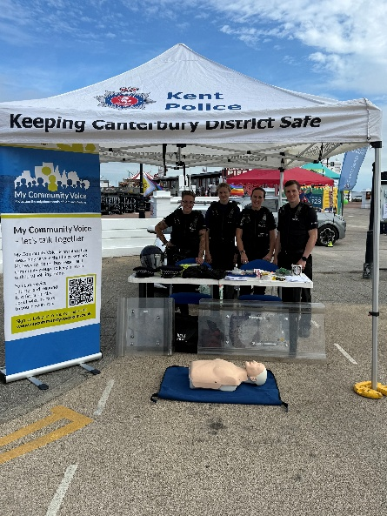
Local officers recently attended Herne Bay Pride, engaging with
the community and promoting My Community Voice.
We also provided non-spiking kits, shared advice on
staying safe and demonstrated basic CPR skills.
Attendees had the opportunity to try on police uniform and
speak with officers in a relaxed setting.
Thank you to everyone who came along and
helped make it such a positive event.

