DISPERSAL AREA
From 1600hrs 3rd July 2026
until 1600hrs 5th July 2026
Including the following areas
The area within the following defined boundary:
The coastline from West Beach to Beach Walk, Inland along Clare Road, West Old Bridge Road to Canterbury Road by Forge Lane and Northwest to West Beach as defined by the map.
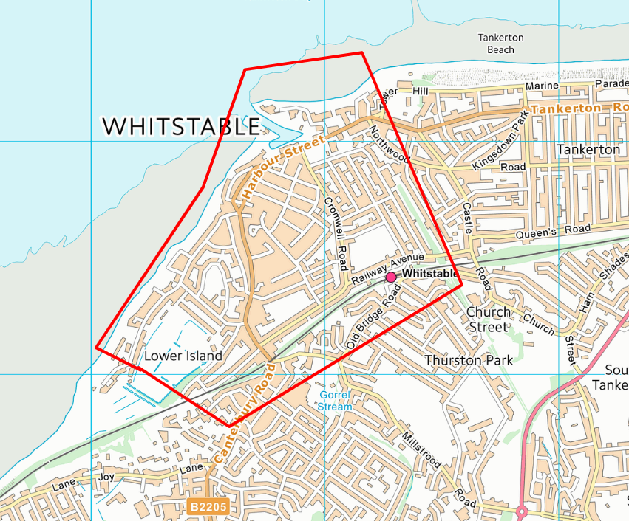

Anyone found acting or likely to cause harassment alarm or distress can be directed to leave the designated area and not return within 24hrs.
Failure to leave can result in arrest.
Sec 35, Anti-Social Behaviour, Crime and Policing Act 2014

