
Road Safety – Speed Enforcement Activity

Get the latest crime statistics
by
v
isiting:

www.kent.police.uk/yourare
a

Beltinge & Reculver

Ward

newsletter

August
202666

.

Here is your monthly update on the work carried out across the wards of Beltinge and Reculver over the past few weeks. Thank you to all residents who continue to report concerns and support our policing efforts. Your information helps us target issues effectively and keep our community safe.

Road safety continues to be a key priority within the ward, with a focus on addressing community concerns around speeding and improving safety for all road users.

Over the past month:

- I have been engaging with residents and gathering feedback to identify the roads within Reculver that are causing the greatest concern in relation to speeding and road safety.

- I liaised with the Kent Police Community Speedwatch Coordinator to obtain and review speeding data from across the area. This information has helped me identify trends, and to pinpoint locations where speeding is most prevalent.

- Targeted speed enforcement activity has already taken place across Herne Bay, with officers carrying out checks at identified hotspot locations and taking action against motorists found to be exceeding the speed limit.

- Further enforcement days are currently being planned, and I plan to deploy speed detection equipment at key locations across the ward to monitor compliance, deter offending, and address residents' concerns regarding speeding traffic.

Ongoing Work – Drug Use and Anti-Social Behaviour at Residential Address

I am continuing to investigate ongoing reports linked to a residential block of flats within the Reculver ward, where concerns have been raised regarding persistent drug use and suspected drug dealing by an occupant in the block.

Over the past month:

- I have attended the address with the local Housing Officer, and we are taking steps to address the ongoing concerns. As part of this collaborative approach, we are exploring a range of measures, including the installation of internal and external CCTV to assist in evidencing the drug dealing and associated criminality.

- The Housing Officer and I are also looking into any potential breaches of tenancy conditions and plan to coordinate a multi-agency response to the issues identified.

- I am still actively exploring the use of a Closure Order for the address and I’m working closely with our Anti-Social Behaviour Officer and building the evidence to obtain a Closure Order. A Closure Order is a legal measure that can be used to restrict access to, or close premises linked to persistent anti-social behaviour, disorder, or criminality, including drug-related activity.

Community Engagement

Over the past month:

- I would like to thank everyone who took the time to attend the Coffee with a Cop events this Summer and share their views and provide valuable information and feedback that assists us in identifying and tackling local concerns.

- This month I have supported colleagues at the Hersden Community Centre for their Emergency Services Day, which was attended by a wide range of partner agencies and members of the public.

- We held a Kent Police community engagement stall where we provided a range of free crime prevention and security items, including UV property marking pens, personal alarm purse bells, security leaflets, stickers, colouring sheets, and other educational safety leaflets.

- One of the highlights of the day was the police van, which proved popular with both children and adults. Visitors had the opportunity to step inside and learn more about the equipment and vehicles we use to keep our communities safe; visitors even got the opportunity to sit in the back of the police cell van.

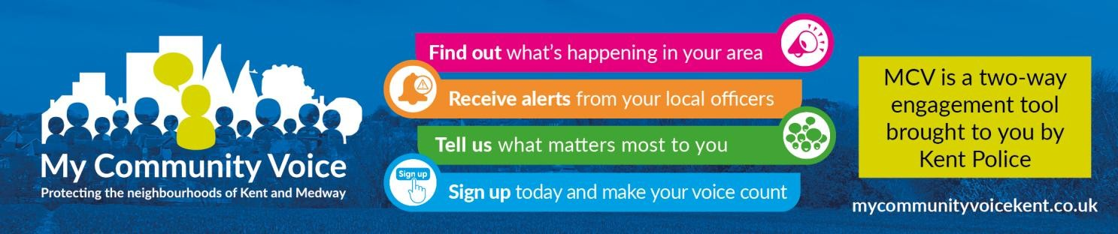
- Supporting our community: By working closely with residents, local partners, and community groups, we aim to build trust, improve safety, and create stronger relationships across the area. Whether it’s providing reassurance, acting on concerns, or helping vulnerable individuals access the support they need, our focus is on being visible, approachable, and proactive. Together, we can continue making our neighbourhood a safer and more positive place to live.

1


Community Engagement: We are committed to engaging with the Coastal Wards community. This includes holding regular community meetings, which are advertised via My Community Voice. We want to hear your concerns and work together to find solutions.

We are committed to keeping you informed. We publish this monthly newsletter and provide updates on local crime trends and the work we are doing to address these issues on My Community Voice.

2

Next month’s engagements:  - Friday 4th August 2026 @ 10:00 – 11:30 – (Heron Leisure Centre) HatHats Coffee, Herne Bay Central, William Street, Herne Bay, CT6 5NX  - Tuesday 8th August 2026 @ 10:00 -11:30 – HatHats Coffee, Reculver, Ct6 6SS.  - Tuesday 22nd August 2026 @ 15:00 -16:30 – Costa Coffee, 6 The Boulevard, Herne Bay, CT6 6GZ. | Your local officer:  PC Jack Roy

