DISPERSAL AREA
From 1600hrs on 17th July 2026
until 1600hrs on 19th July 2026
Including the following areas
The area within the following defined boundary:
The low water mark from Whitstable Beach at the end of Seasalter Beach along the coastline across Whitstable, Tankerton and Herne Bay up to Saxon Shore Way just beyond the Herne Bay Sailing Club. Down along Beacon Road to the junction of Cecil Park. South down Canterbury Road, then along Spencer Road and south underneath Herne Bay Train Station. Fleetwood Avenue junction with Sea Street. Sea Street junction with Lane End then back along the coastline to Whitstable.
Marine Parade junction with Park Avenue, down to Castle Road then west underneath the Whitstable Train Station. From Old Bridge Road to Belmont Road then Canterbury Road. Joy Lane then back up to the coastline.

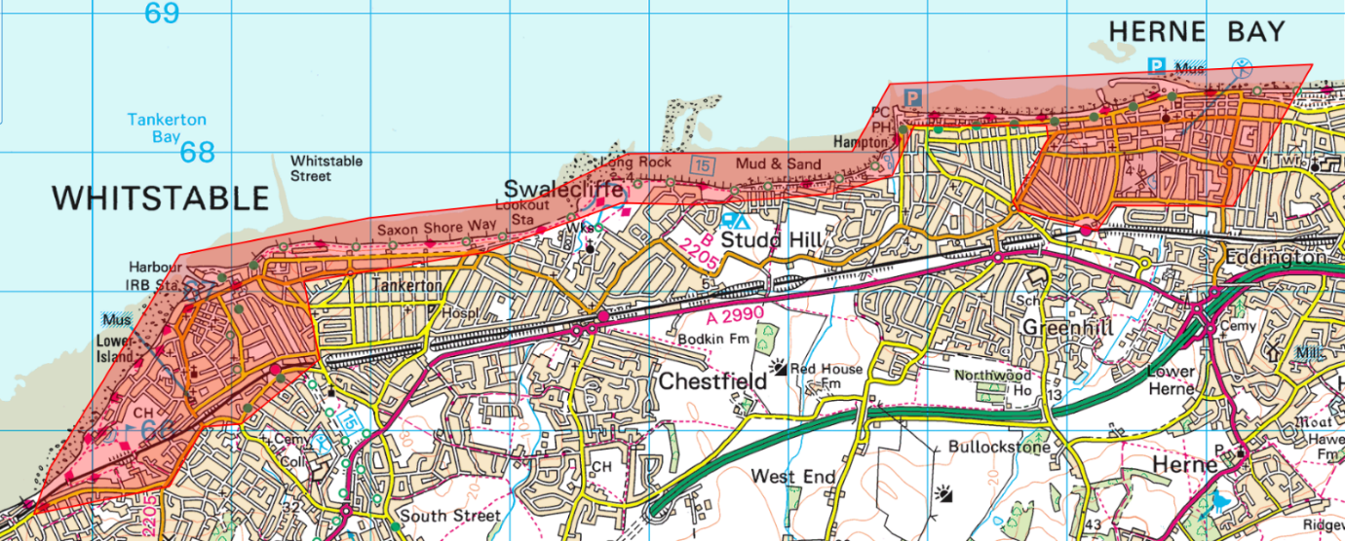
Anyone found acting or likely to cause harassment alarm or distress can be directed to leave the designated area and not return within 24hrs.
Failure to leave can result in arrest.
Sec 35, Anti-Social Behaviour, Crime and Policing Act 2014

